TOWN OF WOOLSEY FEE: $50.00

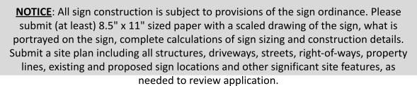
APPLICANT INFORMATION

Name: Company Name: Phone #: Email: Additional Information (if needed):
Zoning of Property:

Property Owner: Phone #: Owner Address:
JOB SITE INFORMATION

Business Name: Contact Person (if applicable): Phone #: Email: Job Site Address:

Free Standing Signs
- No sign shall exceed six (6) feet in height as measured from grade and shall not exceed a total surface area of fifty (50) square feet per side.
- Signs may only be illuminated from an exterior source.

PROPOSED SIGN INFORMATION
TYPE AND DESCRIPTION OF PROPOSED SIGN(S) | DIMENSIONS OF PROPOSED SIGN(S)
FOR WALL SIGN(S) ONLY:
Wall signs shall be allowed on non-residential structures only and shall not extend more than twelve (12) inches from a surface area nor shall the sign exceed a total surface area of ten (10) square feet. No wall sign shall be placed on any roof, gambrel roof, or fake roof or on top of any structure.

AREA OF EXISTING SIGNAGE (IF APPLICABLE)
TYPE OF EXISTING SIGN | SQUARE FOOTAGE | SIGN TO REMAIN?

TOTAL COPY AREA OF EXISTING AND PROPOSED SIGNS:

REQUIRED SETBACKS FROM PROPERTY LINES (IF APPLICABLE):
front: Side: Height of Sign:

Sign Illuminated? □ Yes □ No Electrical Permit #: □ N/A
(If circuit is not existing, a licensed electrical contractor will need to obtain a permit from the building department)

I hereby make application for permit as outlined above, and if same is granted I agree to conform to all building regulations and Town ordinances regulating same and in accordance to plans submitted.
The applicant states that all work to be done is authorized by the owner of said property.

****Submitting application and payment of review fee does NOT constitute approval. You will be contacted within forty to five days regarding approval or denial of this application. ALL final inspections must be called in by applicant/owner for final approval of the sign. *******

Signature of Applicant:
Date:

Authorization to initiate construction has been APPROVED / DENIED with the following comments or special conditions:

By: Date:

This permit has been APPROVED / DENIED with the following comments or special conditions (if any):

By: Date:
Received By:
Final Inspection Performed By: Date:

